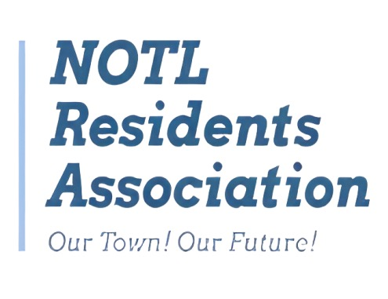
Governance, Finance and Civic Engagement Committee NOTLRA — Meeting Agenda
Date: Friday, May 8
Time: 2:00 PM — 3:30 PM
Location: Board Room, Community Centre
1. 2:00–2:05 — Welcome, attendance, approval of agenda — Chair: Alan; Secretary: ?
2. 2:05–2:10 — Election countdown & key dates recap — (Chair)
3. 2:10-2:15 — Motion to amend Committee’s April 24 decision on 2026 resident survey
4. 2:15-2:25 — Update status of resident survey (Norm)
5. 2:25-3:00 — Discuss issue set for NOTLRA election website and survey — (All)
6. 3:00–3:05 — Candidate engagement plan update – (Bette Ann)
7. 3:05-3:15 — Candidate questionnaire (Chair)
- Additional questions for Board consideration / consolidation of existing questions
- Engage other Committees to contribute questions
8. 3:15–3:20 — Workstream updates & assignments
- Municipal Finance/Infrastructure (Stuart / Tony)
9. 3:20–3:25 — Review action items, owners, and deadlines
10. 3:25–3:30 — Any other business & adjournment

